Samuel Ogunfunmi

Purpose: Solve the following problems using functions with return.

Date: 9/20/20

**Problem 1)**

**1. Algorithm (Solution Plan for the Problem):**

1. Capture 4 values from user in main
2. Create a function called average
3. In the average function, find the average of the 4 values captured in main.
4. Save the average of the 4 numbers in this group.
5. Repeat steps 1-4 three times in order to have 4 groups total
6. Use the average function to find the average of all the group averages
7. Print the averages of each group
8. Print the overall average of averages

**2. Program Source Code (copy and paste from IDE):**

def average(num1,num2,num3,num4): #fucntion made to find the average of 4 numbers

return (num1+num2+num3+num4)/4 #Returns result of 4 inputs averaged to main

def main():

print("---Group 1---")

num1 = float(input("First number: ")) #asks user for number

num2 = float(input("Second number: ")) #asks user for number

num3 = float(input("Third number: ")) #asks user for number

num4 = float(input("Fourth number: ")) #asks user for number

average_1 = average(num1,num2,num3,num4) #Takes 4 inputs and finds the average using the average function

#Result is returned here and saved as average_1

print("---Group 2---")

num1 = float(input("First number: ")) #asks user for number

num2 = float(input("Second number: ")) #asks user for number

num3 = float(input("Third number: ")) #asks user for number

num4 = float(input("Fourth number: ")) #asks user for number

average_2 = average(num1,num2,num3,num4)#Takes 4 inputs and finds the average using the average function

#Result is returned here and saved as average_1

print("---Group 3---")

num1 = float(input("First number: ")) #asks user for number

num2 = float(input("Second number: ")) #asks user for number

num3 = float(input("Third number: ")) #asks user for number

num4 = float(input("Fourth number: ")) #asks user for number

average_3 = average(num1,num2,num3,num4)#Takes 4 inputs and finds the average using the average function

#Result is returned here and saved as average_1

print("---Group 4---")

num1 = float(input("First number: ")) #asks user for number

num2 = float(input("Second number: ")) #asks user for number

num3 = float(input("Third number: ")) #asks user for number

num4 = float(input("Fourth number: ")) #asks user for number

average_4 = average(num1,num2,num3,num4)#Takes 4 inputs and finds the average using the average function

#Result is returned here and saved as average_1

avg = average(average_1,average_2,average_3,average_4) #Finds the average of 4 averages

print("Group 1 Average:", average_1) #prints average 1

print("Group 2 Average:", average_2) #prints average 2

print("Group 3 Average:", average_3) #prints average 3

print("Group 4 Average:", average_4) #prints average 4

print("Total Average:", avg) #prints average of averages

main()

**3. Program Output Screenshots/Screen Print(s) and/or Error Messages:**

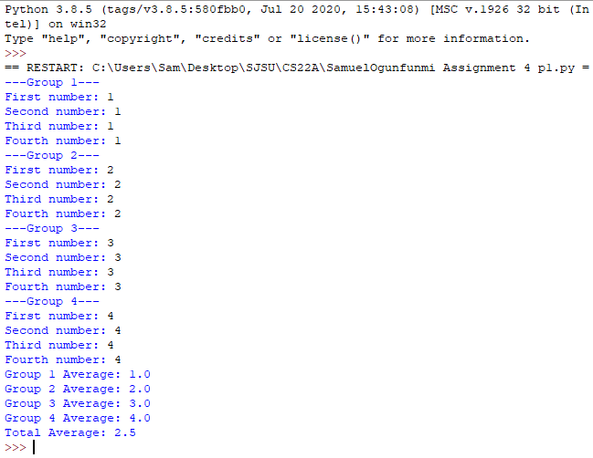

**Problem 2)**

**1. Algorithm (Solution Plan for the Problem):**

1. Create a function that captures users username and password
2. Return the data to the caller in main
3. Call the function and print the username and password in main

**2. Program Source Code (copy and paste from IDE):**

def access():

u = input("Enter username: ")

p = input("Enter password: ")

return u, p

def main():

Username, Password = access()

print("Your usename is:", Username)

print("Your password is:", Password)

main()

**3. Program Output Screenshots/Screen Print(s) and/or Error Messages:**

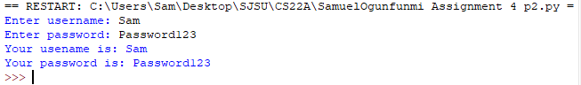

**Problem 3)**

**1. Algorithm (Solution Plan for the Problem):**

1. Ask user for cost to replace structure
2. Create a function to find 80% of the users input (Replacement cost of a building)
3. In the function return the new value to main
4. Print 80% of the buildings replacement cost (minimum insurance value)

**2. Program Source Code (copy and paste from IDE):**

def cost(rep_cost): #Function to calculate min insurance cost

min_insurance = rep_cost * 0.8 #Finds 80% of replacement cost

print("Minimum insurance value: ", min_insurance) #prints min insurance value

def main():

rep_cost = float(input("Replacement cost: ")) #Asks user for replacement cost

cost(rep_cost) #Calls function cost

main()

**3. Program Output Screenshots/Screen Print(s) and/or Error Messages:**

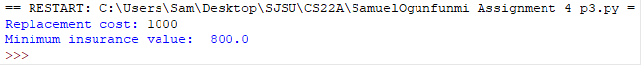

**Problem 4)**

**1. Algorithm (Solution Plan for the Problem):**

1. Create a function to convert fat and carb grams to calories
2. In main, ask the user for number of fat grams
3. In main, ask the user for number of carbohydrate grams
4. Enter conversion formula in function and return new values to main
5. Print the results for fat and carb calories

**2. Program Source Code (copy and paste from IDE):**

def calorie_conversion(fat_g,carb_g):

fat_cal = fat_g * 9 #Converts fat grams to calories

carb_cal = carb_g * 4 #Converts carb grams to calories

return fat_cal,carb_cal #Returns new calories values to main

def main():

fatgrams = float(input("Fat grams: ")) #Asks user for total fat grams eaten

carbgrams = float(input("Carbohydrate grams: ")) #Asks user for total carb grams eaten

fat_calories, carb_calories = calorie_conversion(fatgrams,carbgrams) #Calls function and defines variables for calories

print("Calories from fat grams:", fat_calories) #Prints fat calories

print("Calories from carbohydrate grams:", carb_calories) #Prints carb calories

main()

**3. Program Output Screenshots/Screen Print(s) and/or Error Messages:**

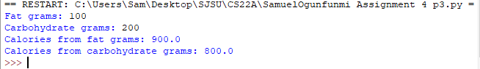

**Conclusion/What you learned writing this program and what problems you encountered.**

I learned how to return values from a function to main. A problem I encountered was getting question #1 to run correctly. Abstraction helped me a lot to solve that problem.